**Explorers Residencies**

|  |  |
| --- | --- |
|  | Outside In is offering 3 residencies at The New Art Gallery Walsall and The Herbert Art Gallery & Museum. |
| Counties Archive - Girlguiding Midlands | You can apply for this if you are:   * An artist who is neurodivergent * You live in the Midlands area of the United Kingdom.   You cannot apply if you are in full-time education, but you can apply if you are in part-time education. |
|  | If you have a questions or would like help with submitting for this opportunity or signing up to Outside In you can contact José.  José will also be running the artist support days on these dates:  • Thursday 9 June at The New Art Gallery Walsall   * Thursday 16 June at The Mac, Cannon Hill Park.   To speak to José or to book an artist support session please call or email.  **Email:** [**jose.sunshine-okoro@outsidein.org.uk**](mailto:jose.sunshine-okoro@outsidein.org.uk)  **Phone: 07496 997 333** |
|  | If you are selected you will get:   * A virtual or in person studio visit and curatorial guidance * Support from a professional artist * Additional budget for access costs * An opportunity to present your artwork and take part in the final event at the gallery. * Ongoing support during your residency |
|  | If you are selected you will receive £1475 as a fee. This must also include your travel costs.  You will also get £300 to spend on art materials. |
|  | To apply please send us up to 6 images of your artwork.  If you can, we would also like to find out more about you and your artwork and why you would like this residency.  You can tell us this information over the phone, in an email or in a video. Please send this to José Sunshine Okoro.  **Email:** [**jose.sunshine-okoro@outsidein.org.uk**](mailto:jose.sunshine-okoro@outsidein.org.uk)  **Phone: 07496 997 333**  If you would like to make a phone application please call José to arrange a time to do this. |
| Clock with words TIME FOR CHANGE Clipart Image | The deadline is on Monday 20 June at 9am. |
|  | * **Residency 1** The New Art Gallery Walsall from 18 July – 21 August 2022. For 2 days a week. * **Residency 2** The New Art Gallery Walsall 15 August - 18 of September 2022. For 2 days a week. * **Residency 3** The Herbert Art Gallery residency 10 October - 11 November 2022. For 2 days a week. |
|  **| Outside In is working with Project Art Works on the Explorers Project.  This is a large project that is taking place around the United Kingdom. |
| Image result for thumbs up | Good luck! |

**Key words**

**Midlands**

The Midlands is an area in the United Kingdom, big cities in this area include Birmingham, Coventry, Leicester, Nottingham, Stoke-on-Trent, Derby and Wolverhampton.

**Paid opportunities**

This means you will receive money for taking part in this project.

**Residency**

A residency is an opportunity for an artist to live and make artwork outside of their usual home or studio.

The point of a residency is to give artists time to think about their art and even create something new.

**Neurodivergent**

Neurodivergent is a word that is used to describes people whose brains function differently from most of the population. It is usually something that has been passed on genetically, such as autism and ADHD. Some other conditions are also considered neurodivergent because of how they affect a person and the way their brain works. We include people who have Down’s Syndrome, have Learning Disabilities or other lifelong neurological difference in this description as well.

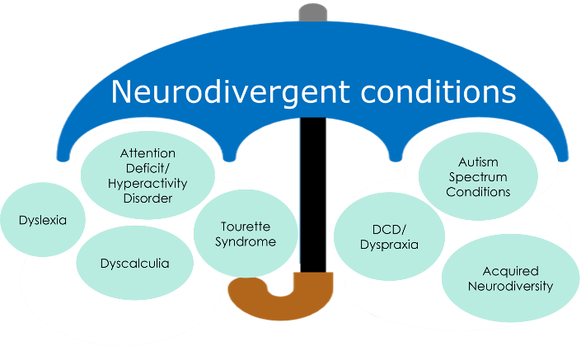

For more information on this project please check: [www.outsidein.org.uk](http://www.outsidein.org.uk)