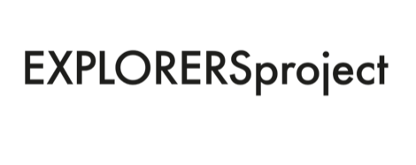

Explorers July – November 2022.

APPLICATION FORM
Submissions are now open for artists identifying as neurodivergent to apply for Explorers residencies with Outside In and Project Art Works in collaboration with The New Art Gallery Walsall and The Herbert Art Gallery & Museum. Between July – November 2022, three artists will receive studio support to develop new work or work-in-progress. The deadline is 9am, 20 June 2022.

The successful artists will each receive:
- £1475 fee (inclusive of travel)
- Up to £300 for materials
- virtual or in person studio visits and curatorial guidance, advocacy and a presence across Outside In, The New Art Gallery Walsall and The Herbert Art Gallery online platforms
- Access to remote technical advice, as appropriate
- Access to a Lead Artist for 1 x visit
- Additional budget for access costs including support at our Artist Support Days for guidance on your application

These residencies have been created in partnership with Project Art Works and are open to artists who identify with having ‘complex’ needs or who identify as neurodivergent. The term ‘complex needs’ embraces a number of neurodiverse states of being such as severe learning disability and/or autism and/or cognitive impairments and/or behaviours described as challenging that combine to produce multiple and intersecting support needs. Sometimes these are also combined with complex physical needs as well. People with learning disabilities and behaviours that challenge are some of the most excluded in society. This is because they are very often dependent on carers and agencies for access to the wider world and experiences such as art and culture.

Key dates:
Submissions open: Wednesday 25 May 2022.
Applications close: Monday 20 June 2022. 9.00am.
Selection announced: 27 June 2022
Announcement (for all residencies): Monday 4 July 2022.

Selected artists will be notified by email. Residencies will be announced via Outside In, The New Art Gallery Walsall and The Herbert Art Gallery digital and online platforms.

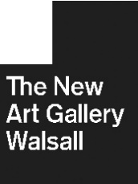
Residency dates:

The New Art Gallery Walsall Residencies:

Residency 1: 18 July – week ending 21 August 2022 for 5 weeks at 2 x days a week.
Lead Artist studio visit to be confirmed in consultation with artist chosen

Residency 2: 15 August – week ending 18 September 2022
Lead Artist studio visit to be confirmed in consultation with artist chosen

There will be a Crossover Week, where both artists based at The New Art Gallery Walsall will be present in the studio: (15 – 21 August) for dialogue, exchange and support.
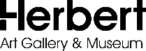
The Herbert Art Gallery & Museum Residency:

Residency 3: 10 October – week ending 11 November 2022 for 5 weeks at 2 days per week.

There will be an opportunity for the artist to present their work through a final output event TBC in consultation with the artist.

Lead Artist studio visit to be confirmed in consultation with artist chosen

If you have a question or would like help with submitting for this opportunity or signing up to Outside In, you can contact José Sunshine-Okoro Midlands Hub Programme Manager.

José will also be attending the artist support days on these dates:

• Thursday 9 June at The New Art Gallery Walsall

- Thursday 16 June at The Mac, Cannon Hill Park.

To speak to José or to book an artist support session please call or email.
Email: jose.sunshine-okoro@outsidein.org.uk Phone: 07496 997 333

How to apply:
Please complete the following form and return your application by email to:
Email: jose.sunshine-okoro@outsidein.org.uk Telephone: 07496 997 333

If you are a representative applying on behalf of someone, then please supply your contact details here:

Representative contact details:

Name:

Address:

Telephone Number:

Email address:

- Applicant Personal details:

Name:

Address:

Telephone number:

Email:

Social Media handles:

Website details (if you have one):

Preferred residency slot (please state 1, 2, 3 or ‘no preference’):

- Artist Statement (no more than 200 words)
We would like to find out more about you as an artist and your practice. This can be in the form of a phone call, video or can be written on your behalf.

- Residency statement (no more than 500 words)
Please provide a short statement describing the points below. This can also be provided in the form of a phone call, video or can be written on your behalf:
- How you would like to use the residency opportunity (your proposed project, the possible direction/outcome of your project)
- How you might engage an audience with your work and experiences
- Why this residency will benefit you, your practice and long-term aspirations at this particular time

- Visuals
Please provide examples of your current practice and recent work produced within the last 3 years in the form of one of the following:

- a maximum of 6 images
- a direct link to a showreel of film and video work (maximum duration 5 minutes) uploaded to YouTube or Vimeo

Please label/caption your images so that selectors have a full picture of the work and its context. This is especially important for installation images that may also feature the work of other artists.

If you would like to apply using video it would be helpful if you could upload this to YouTube or Vimeo and send a link in your application, directing us to this work. Videos should be no longer than 5 minutes long. Sound files should be no longer than 3 mins long and should be sent via WeTransfer. If you need any support with this, please contact us.

- Your Support or Access Needs:
To help us to support you please tell us about any access or support needs:

Signature: Date:

